1. High Level Architecture Overview
AssetFlow follows a multi tier, layered architecture designed for scalability and maintainability.
Logical Flow
Client → API Layer → Service Layer → Repository Layer → Database
This separation ensures:
- Clean code structure
- Scalability
- Testability
- Maintainability

2. Architecture Diagram (Conceptual View)
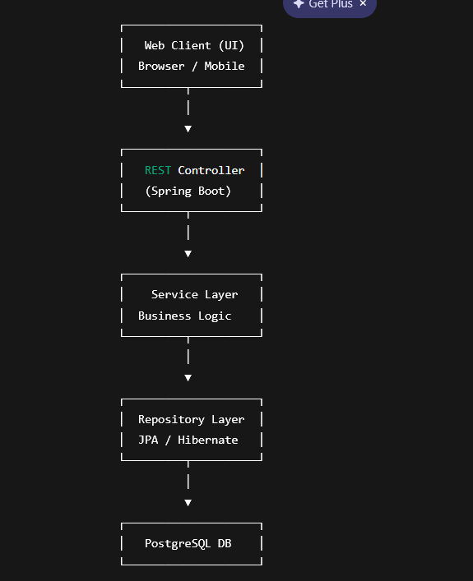

3. Layer by Layer Explanation
3.1 Client Layer
This is the frontend interface.
Responsibilities:
- Display dashboards
- Send booking requests
- Display reports
- Authenticate users
The client communicates with backend via HTTP REST API.
No business logic is handled here.

3.2 Controller Layer (API Layer)
This layer:
- Receives HTTP requests
- Validates request data
- Maps endpoints
Example endpoints:
- POST /login
- POST /assets
- GET /bookings
- POST /bookings/request
Controllers do not contain heavy logic. They delegate to services.

3.3 Service Layer (Business Logic Core)
This is the most important layer.
Responsibilities:
- Booking conflict detection
- Role authorization checks
- Asset status transitions
- Maintenance scheduling
- Utilization calculations
- Transaction handling
Example:
When a booking request is made:
- Check asset availability
- Check time conflicts
- Lock record
- Save booking
- Update asset status
This layer ensures system intelligence.

3.4 Repository Layer
Handles:
- Database queries
- CRUD operations
- ORM mapping via JPA or Hibernate
Each entity has a corresponding repository:
- UserRepository
- AssetRepository
- BookingRepository
No business logic here.

3.5 Database Layer
PostgreSQL stores:
- Organizations
- Users
- Roles
- Assets
- Bookings
- MaintenanceRecords
- AuditLogs
Multi tenant design ensures each organization’s data is isolated using organization_id foreign keys.

4. Security Architecture
Authentication:
- JWT based authentication
- Token issued on login
Authorization:
- Role based access control
- Admin, Staff, Super Admin roles
Flow:
- User logs in
- Server generates JWT
- Client stores token
- Token sent with each request
- Backend validates token

5. Multi Tenant Design Explanation
Each record includes organization_id.
Example:
Asset
- id
- name
- organization_id
Booking
- id
- asset_id
- organization_id
This ensures:
- Data isolation
- Security between organizations
- Scalability
No organization can access another’s data.

6. Scalability Considerations
- Stateless REST API
- Database indexing
- Pagination for large queries
- Docker containerization
- Cloud deployment readiness
Can later be extended to microservices if scaling increases.

7. Booking Conflict Control Architecture
To prevent double booking:
- Use database transaction
- Use optimistic locking or timestamp validation
- Validate booking period before save
This ensures concurrency safety.

8. Why This Architecture Is Strong Academically
It demonstrates:
- Layered architecture principles
- Separation of concerns
- RESTful API design
- ORM mapping
- Security implementation
- Multi tenant SaaS architecture
- Transaction management
- Concurrency control

